|  |  |  |  |  |
| --- | --- | --- | --- | --- |
| **POLYTECHNIC UNIVERSITY OF THE PHILIPPINES**  **COLLEGE OF ENGINEERING**  **COMPUTER ENGINEERING DEPARTMENT**      TOTAL QUALITY IN COMPUTER ENGINEERING    Whistle Flashlight For Emergency Survival Tool    PROJECT CHARTER  DOCUMENT    Section BSCOE 5-1D  Group No 3 | | | | |
| **NO** | **MEMBERS (Alphabetical Order)** | **CRITERIA** | **GRADE** |  |
| 1 | Cagomoc Niña Jaira Lael | Document Format Consistency (20%) |  |
| 2 | Calilung, Kristal |
| 3 | Kitts, Johndell | Problem Statement (20%) |  |
| 4 | Macatangay senon jayson |
| 5 | Tan, Frederick | Project Goal (20%) |  |
| 6 |  |
| 7 |  | Scope and Benefits (20%) |  |
| 8 |  |
| 9 |  | Timeline (20%) |  |
| 10 |  |
| **FINAL GRADE**      Instructor    **DR. LUTZ REYES**  2022 | | | |

|  |  |  |  |  |
| --- | --- | --- | --- | --- |
| **1. CHANGE RECORD:** | |  |  | |
| **Date** | **Author** | **DocVer** | **Change Reference** |  |
| 04-27-  2022 | * Cagomoc Niña   Jaira Lael   * Calilung,   Kristal   * Kitts, Johndell * Macatangay senon jayson * Tan, Frederick | Version  1.0 | Initial Draft |
|  |  |  |  |
|  |  |  |  |
|  |  |  |  |
|  |  |  |  |
|  |  |  |  |
|  |  |  |  |
|  |  |  |  |
|  |  |  |  |
|  |  |  |  |
|  |  |  |  |
|  |  |  |  |
|  |  |  |  |
|  |  |  |  |
|  |  |  |  |
|  |  |  |  |
|  |  |  |  |
|  |  |  |  |
|  |  |  |  |
|  |  |  |  |
|  |  |  |  |
|  |  |  |  |
|  | | | |

|  |
| --- |
| *2.* **PROBLEM STATEMENT: (***Problem or opportunity the project will address. How often does it occur? How do we know it is a problem? What is the impact of the problem?)*    ←Margin starts here  How can people easily be notice in times of Calamity and Natural Disaster in order to be rescue?  The impact of the problem is to help rescue more people. |

|  |
| --- |
| **3. PROBLEM GOALS:** *(What will be accomplished “MEASURABLE”? Example: To improve the Project from [baseline capability] to [target capability] by [target date])*    ←Margin starts here  We need a tool that is portable, reliable, and effective.  Intensity of the light |

|  |
| --- |
| **4. SCOPE:** *(Boundaries, constraints, restrictions or limits)*      ←Margin starts here    The Philippines is a Southeast Asian archipelago. It is a group of around 7,640 islands located in the western Pacific Ocean. Thus, natural calamities are a common disaster in our nation. Typhoons, flooding, landslides, earthquakes, and volcanic eruptions are all natural disasters in the Philippines. Heavy rains, which could continue for five to seven days, are expected, potentially causing flooding and landslides. It has the potential to harm and destroy millions of commercial crops, livestock, homes, and businesses, as well as cost human lives.  In keeping with these goals, our product intends to provide assistance to people in times of need. Typhoons, landslides, earthquakes, and volcanic eruptions are among the natural disasters that require immediate action. It's compact and lightweight, so you can take it with you everywhere you go. Our invention serves two purposes: it may be used as a flashlight, which is a more convenient and safe alternative to using a candle stick. A switch on our flashlight may be adjusted to turn it on, off, or signal danger (distress SOS signal). The second type is a whistle that can be used by blowing air into the opening area of the whistle using the mouth.  Though our device is primarily designed for usage in natural catastrophe situations, it can be used for other applications. When you're in a jam, our product comes in handy, such as when you're alone at night and need self-defense, especially if you're a woman. Second, when there is a sudden change in electricity in your neighborhood, it can also be used as an emergency flashlight. And there are numerous other applications.  Because our device has a 3000mAh rechargeable battery, we can only use the flashlight for a limited time. It is dependent on the user's behavior. However, if utilized in a typical manner, the battery can last up to 5 hours. Also, because our device is constructed of plastic and is not waterproof, it may not work if submerged in water for an extended period of time. The whistle, on the other hand, can be used indefinitely with or without a charge or when submerged in water. |

|  |
| --- |
| 1. **BENEFITS:** *(Translate the project’s goal into Hard and Soft Benefits)*      * 1. **HARD BENEFITS:** *(Indicate tangible benefits, cost)*     ←Margin starts here     * + - Low Cost of Operations       * Calculated by combining variable and fixed costs and dividing by total number of units produced.     - Reduction in Unit Cost of Production       * The total amount of expenses incurred by a company to produce a specific quantity of goods or services, divided by the quantity produced. • Reduction in Transaction Cost       * The fees paid to trade a security, such as a broker's commission and spreads, or to make any trade in a market.     - Reduction in Transportation Cost       * All costs associated with the transportation of raw materials, finished goods, and employees.     - Reduction in Manpower       * Also known as downsizing. It eliminates a large number of employees in an effort to cut costs.     - Increased throughput, resulting in increased sales or revenue       * In general, high throughput indicates that a company can produce a product or service more efficiently than competitors.        * 1. **SOFT BENEFITS:** *(Indicate intangible benefits)*     ←Margin starts here     * + - Reduction in Cash Flow       * The flow of funds into and out of a business. • Reduction in need for working capital       * Shortening the cash conversion cycle so that, at any given time, it has a reasonable amount of cash or liquid resources on hand to cover operational expenses.     - Avoidance of capacity enhancement       * It measures any actions taken to avoid incurring future costs.     - Increased safety in the workplace |

|  |  |
| --- | --- |
|  | − A workplace that is reasonably safe for all employees and actively prevents it from becoming unsafe. |
| • | Increased employee satisfaction   The degree to which employees are satisfied with their jobs and work environment. |
| • | Increased customer satisfaction   Defined as a measurement that assesses how satisfied customers are with a company's products, services, and capabilities. |

**6.**

**ORGANIZATIONAL CHART**

←

Margin starts here

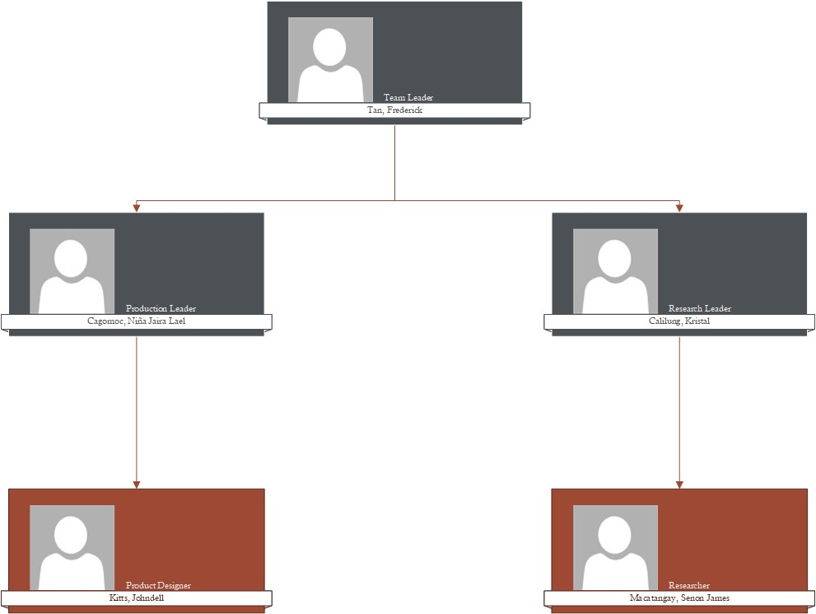

**7.**

**TIMELINE**

**:**

*(*

*Milestones for expected completion by phase*

*)*

**7.1.**

**MILESTONES OF THE PROJECT**

←

Margin starts here

-

April

20

, 2022

-

Discussion of what project are we going to make

-

April 27, 2022

–

Brainstorming ideas and features of the product

-

May 4, 2022

–

Created the initial draft of the project

**7.2.**

**WORK BREAKDOWN STRUCTURE (WBS)**

←

Margin starts here

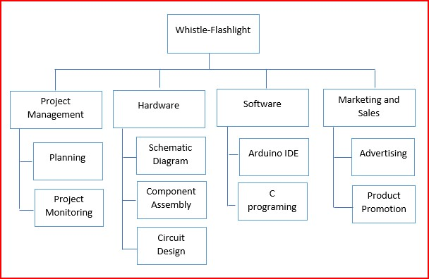

|  |  |  |  |  |  |  |  |  |  |  |  |  |  |  |  |  |  |  |  |  |  |  |  |  |
| --- | --- | --- | --- | --- | --- | --- | --- | --- | --- | --- | --- | --- | --- | --- | --- | --- | --- | --- | --- | --- | --- | --- | --- | --- |
| **8. SIGN OFF:** *(Signature of key sponsors, subject matter expert heads)*       |  |  |  |  | | --- | --- | --- | --- | | Name | Position | Signature | Date Signed | |  |  |  |  | |  |  |  |  | |  |  |  |  | |  |  |  |  | |  |  |  |  | |

Project Charter - Page